Name:
Date:
Block:
WORK Practice
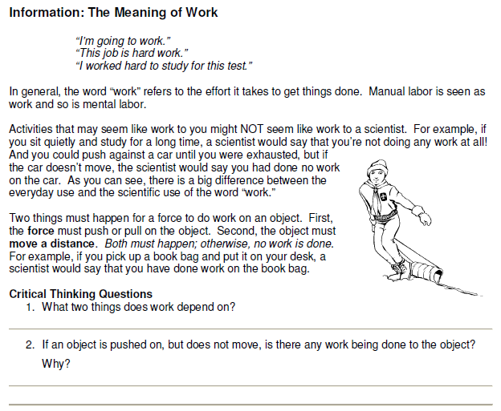
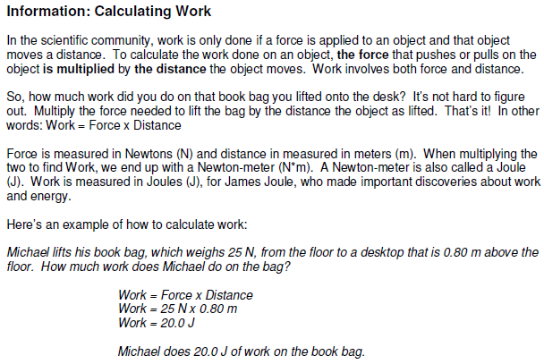
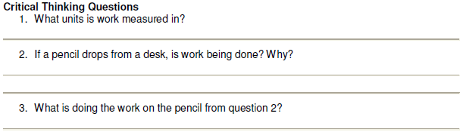
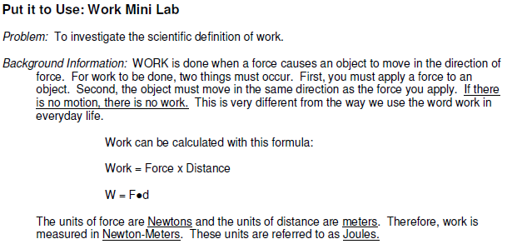
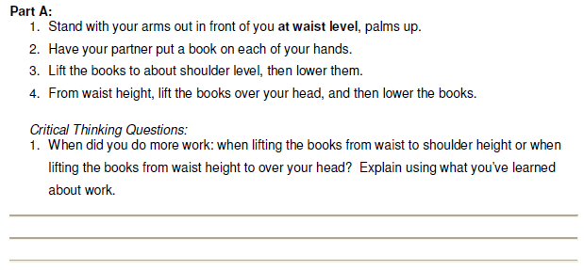
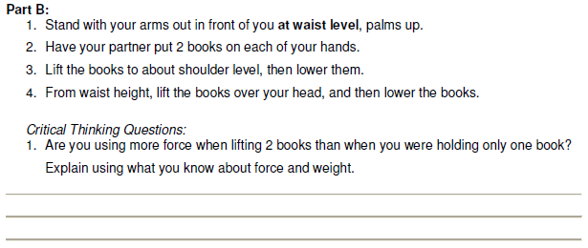
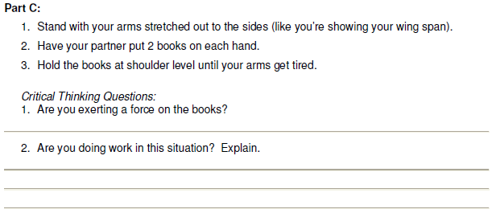

Work has a very special meaning for scientists. Work is done when a force causes something to move. When an object does not move, even though there is a force exerted on it, no work has been done. Something must be moved for work to be done. The amount of work done depends upon the amount of force used and the distance that an object is moved.

1. A boy holds a heavy package for one hour. He is very tired but has not done any work.
Explain why he did not do any work.
____________________________________________________________________________

2. A girl is coasting on a bicycle. The bicycle is moving very fast but she is not doing any work.
Explain why no work is being done.
____________________________________________________________________________

3. Why is no work being done when a rocket ship moves through space?
____________________________________________________________________________
4. Would you do more work pushing open an unlocked door or pushing as hard as you can against a locked door? Explain.
____________________________________________________________________________

5. You push a shopping cart and cause the cart to move. Have you done any work? How do you
know?
____________________________________________________________________________

6. Suppose you stop pushing on the cart, but the cart keeps moving. Are you doing any work
now? How do you know?
____________________________________________________________________________

7. Circle the letter of each sentence below that describes work being done.
- John is thinking about his math test.
- Joe is rowing a boat across the lake.
- Sue is standing in line holding her groceries.
- A pillar is holding up the ceiling.
- Kathy handed a pencil to Sam.

Work Calculation Practice
- A 45 N girl sits on an 8 N bench. How much work is done on the bench?

- A boy lifts a 30 N dragon 2 meters above the ground. How much work did the boy do on the dragon?

- Which of the following is having work done on it? (Circle all that apply.)
  - a grocery bag as you lift it up
  - a crane moving dirt
  - a crate as you push it along the floor
  - a person sitting on a bench

- In the equation for work, F is the____________ applied to the object and d is the _______________ through which the force is applied.

- If you are in a car that is being pulled down a 56.0 m path with a force of 12.5 N, what is the work done on the car?

- A crane does work of 13,500 J with a force of 5200 N to lift a beam. How far can the beam be lifted (in meters)?

- A 600 kg great white shark is lurking below an observation cage. His movement is being studied from a series of motion sensors below the boat. The shark leisurely charges the cage, strikes it and makes the cage rattle.

Later, the shark returns for another run at the cage. The shark strikes the cage with 12,800 N of force. The shark traveled for 10 m in making its run.

The cage is designed to withstand 124,500 N-m of “work” before it breaks.
Should the man in the cage be worried? Explain.

- How much work is done in holding a 15 N sack of potatoes while waiting in line at the grocery store for 3 minutes?

- A force of 5.0 N moves a 6.0 kg object along a rough floor at a constant speed of 2.5 m/s. How much work is done in 25 sec?

